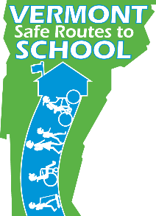
Let’s Go For a Ride!

Join us on May 4th to celebrate
Bike to School Day!
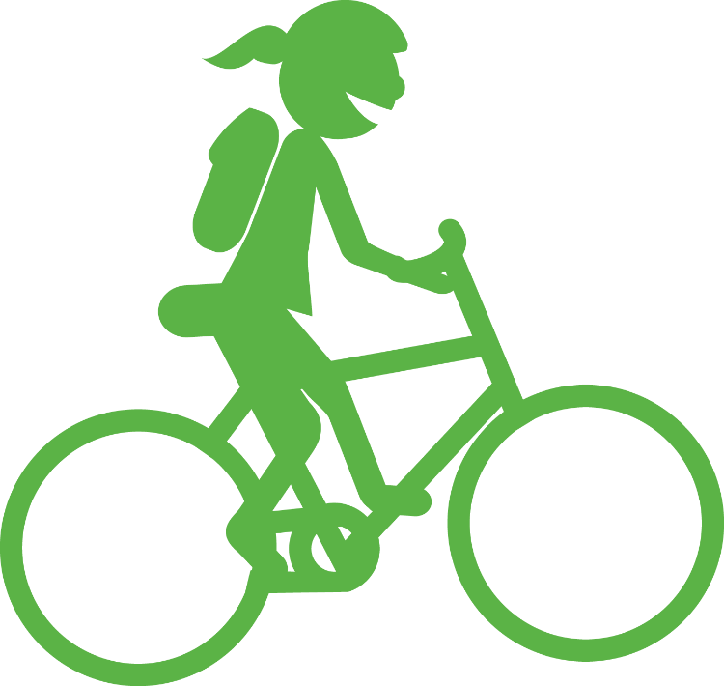
Students from
[type your school here]
are joining students all over Vermont to celebrate the benefits of biking to school.
It is our goal to have all students participate.

Please contact us to learn more:
[enter contact info here]

[enter any additional information here]
www.saferoutes.vermont.gov
Walk with me!
Join us on October 5th to celebrate
Walk to School Day!
Students from
[type your school here]
are joining students all over Vermont to celebrate the benefits of walking to school.
It is our goal to have all students participate.

Please contact us to learn more:
[enter contact info here]

[enter any additional information here]
www.saferoutes.vermont.gov

