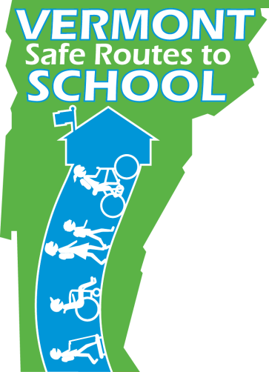
Riverside Elementary School News
Date

Safe Routes to School Program Launches
at Riverbrook Elementary!

Safe Routes to School (SRTS) helps and encourages kids and families to walk and bike to school as part of a daily routine. [Riverbrook Elementary] school is implementing the SRTS program for the first time this year, and we hope you will become involved! Our goal is to get as many kids as possible safely walking and biking to school!
Who Benefits?
· Safe Routes to School improves safety, visibility, accessibility, and convenience of key routes to and from school. And it’s fun!
· Skill-building activities and street improvements increase the safety of pedestrians and bicyclists, as well as motorists, and help overcome barriers to walking and biking.
· Walking and biking are social activities that allow more contact with people and easier exploration of the neighborhood and neighborhood schools.
· More kids walking and biking to school increases the eyes and ears on the street, which minimizes the threat of crime.
· Kids who walk and bike to school gain freedom, independence, empowerment, self advocacy, and positive life-long habits.
· Regular physical activity improves health, fitness, self-esteem, energy, relaxation, and alertness and behavior in school.
· Safe Routes reduces traffic congestion and air
Parents like yourself and other people in the school
Here are some of the fun and exciting activities you can participate in this year!
- INTERNATIONAL WALK + ROLL TO SCHOOL DAY
October 8th
Join others in the city and around the world in celebration. Bring visibility to walking and biking conditions and inspire positive change in your neighborhood.
- WALK + BIKE SCHOOL BUSES
Imagine the school bus, but with NO BUS! Groups of kids and adult volunteers walk or bike together along routes to and from school. We will help to organize regular “Buses” at your school.
- WALK AND BIKE ACROSS AMERICA
One class or the whole school can plot their miles walked or biked on a map and see how far they can get. Great opportunity to learn about another region of the country.
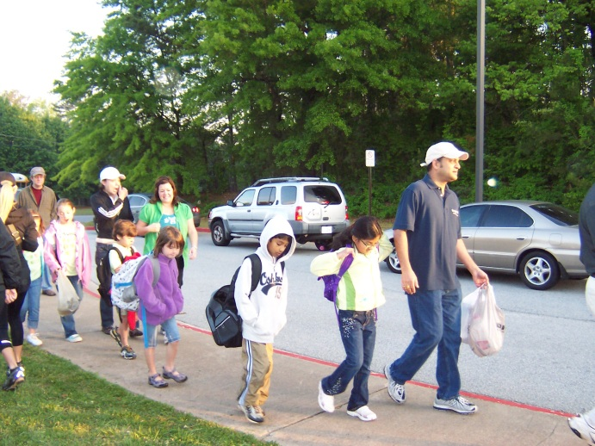
Why we need your help!
It’s all about you: your community, your neighborhood, your perceptions and your habits. We want to know what your concerns are and how we can address them. We will provide many opportunities for you to get involved—we hope you’ll give our activities
a try!
To get involved contact Jane Smith at 802.xxx.xxxx or jane@email.com

